Copyrighted material licensed to Toni Bonàs on 2026-05-06 for licensee's use only.
CIE 140:2019
UDC:
628.931
628.971
628.971.6
Descriptor:
Artificial lighting: Design and calculation Exterior lighting
Street lighting
No further reproduction or networking is permitted. Distributed by Accuris, https://accuristech.com.
ISBN 978-3-902842-56-5
DOI: 10.25039/TR.140.2019
TECHNICAL REPORT
Road Lighting Calculations, 2nd Edition

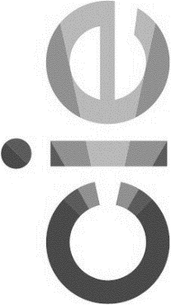


THE INTERNATIONAL COMMISSION ON ILLUMINATION
The International Commission on Illumination (CIE) is an organization devoted to international co -operation and exchange of information among its member countries on all matters relating to the art and science of lighting. Its membership consists of the National Committees in about 40 countries.
The objectives of the CIE are:
- To provide an international forum for the discussion of all matters r elating to the science, technology and art in the fields of light and lighting and for the interchange of information in these fields between countries.
- To develop basic standards and procedures of metrology in the fields of light and lighting.
- To provide guidance in the application of principles and procedures in the development of international and national standards in the fields of light and lighting.
- To prepare and publish standards, reports and other publications concerned with all matters relating to the science, technology and art in the fields of light and lighting.
- To maintain liaison and technical interaction with other international organizations concerned with matters related to the science, technology, standardization and art in the fields of l ight and lighting.
The work of the CIE is carried out by Technical Committees, organized in six Divisions. This work covers subjects ranging from fundamental matters to all types of lighting applications. The standards and technical reports developed by these international Divisions of the CIE are accepted throughout the world.
A plenary session is held every four years at which the work of the Divisions and Technical Committees is reported and reviewed, and plans are made for the future. The CIE is recognized as the authority on all aspects of light and lighting. A s such it occupies an important position among international organizations.
LA COMMISSION INTERNATIONALE DE L'ECLAIRAGE
La Commission Internationale de l'Eclairage (CIE) est une organisation qui se donne pour but la coopération internationale et l'échange d'informations entre les Pays membres sur toutes les questions relatives à l'art et à la science de l'éclairage. Elle est composée de Comités Nationaux représentant environ 40 pays.
Les objectifs de la CIE sont :
- De constituer un centre d'étude international pour toute matière relevan t de la science, de la technologie et de l'art de la lumière et de l'éclairage et pour l'échange entre pays d'informations dans ces domaines.
- D'élaborer des normes et des méthodes de base pour la métrologie dans les domaines de la lumière et de l'éclairage .
- De donner des directives pour l'application des principes et des méthodes d'élaboration de normes internationales et nationales dans les domaines de la lumière et de l'éclairage.
- De préparer et publier des normes, rapports et autres textes, concernant to utes matières relatives à la science, la technologie et l'art dans les domaines de la lumière et de l'éclairage.
- De maintenir une liaison et une collaboration technique avec les autres organisations internationales concernées par des sujets relatifs à la science, la technologie, la normalisation et l'art dans les domaines de la lumière et de l'éclairage.
Les travaux de la CIE sont effectués par Comités Techniques, organisés en six Divisions. Les sujets d'études s'étendent des questions fondamentales, à tous les types d'applications de l'éclairage. Les normes et les rapports techniques élaborés par ces Divisions Internationales de la CIE sont reconnus dans le monde entier.
Tous les quatre ans, une Session plénière passe en revue le travail des Divisions et des Comités Techniques, en fait rapport et établit les projets de travaux pour l'avenir. La CIE est reconnue comme la plus haute autorité en ce qui concerne tous les aspects de la lumière et de l'éclairage. Elle occupe comme telle une position importante parmi les organisations internationales.
DIE INTERNATIONALE BELEUCHTUNGSKOMMISSION
Die Internationale Beleuchtungskommission (CIE) ist eine Organisation, die sich der internationalen Zusammenarbeit und dem Austausch von Informationen zwischen ihren Mitgliedsländern bezüglich der Kunst und Wissenschaft der Lichttechnik widmet. Die Mitgliedschaft besteht aus den Nationalen Komitees in rund 40 Ländern.
Die Ziele der CIE sind:
- Ein internationales Forum für Diskussionen aller Fragen auf dem Gebiet der Wi ssenschaft, Technik und Kunst der Lichttechnik und für den Informationsaustausch auf diesen Gebieten zwischen den einzelnen Ländern zu sein.
- Grundnormen und Verfahren der Messtechnik auf dem Gebiet der Lichttechnik zu entwickeln.
- Richtlinien für die Anwendung von Prinzipien und Vorgängen in der Entwicklung internationaler und nationaler Normen auf dem Gebiet der Lichttechnik zu erstellen.
- Normen, Berichte und andere Publikationen zu erstellen und zu veröffentlichen, die alle Fragen auf dem Gebiet der Wissenschaft, Technik und Kunst der Lichttechnik betreffen.
- Liaison und technische Zusammenarbeit mit anderen internationalen Organisationen zu unterhalten, die mit Fragen der Wissenschaft, Technik, Normung und Kunst auf dem Gebiet der Lichttechnik zu tun haben.
Die Arbeit der CIE wird durch Technische Komitees geleistet, die in sechs Divisionen organisiert sind. Diese Arbeit betrifft Gebiete mit grundlegendem Inhalt bis zu allen Arten der Lichtanwendung. Die Normen und Technischen Berichte, die von diesen international zusammengesetzten Divisionen ausgearbeitet werden, sind auf der ganzen Welt anerkannt.
Alle vier Jahre findet eine Session statt, in der die Arbeiten der Divisionen berichtet und überprüft werden, sowie neue Pläne für die Zukunft ausgearbeitet werden. Die CIE wird als höchste Autorität für alle Aspekte des Lichtes und der Beleuchtung angesehen. Auf diese Weise unterhält sie eine bedeutende Stellung unter den internationalen Organisationen.

Published by the

COMMISSION INTERNATIONALE DE L'ECLAIRAGE
CIE Central Bureau Babenbergerstrasse 9, A-1010 Vienna, AUSTRIA
Tel: +43(1)714 31 87
e-mail: ciecb@cie.co.at www.cie.co.at

Copyrighted material licensed to Toni Bonàs on 2026-05-06 for licensee's use only.
No further reproduction or networking is permitted. Distributed by Accuris, https://accuristech.com.
© CIE 2019 - All rights reserved

ISBN 978-3-902842-56-5
DOI: 10.25039/TR.140.2019
TECHNICAL REPORT
Road Lighting Calculations, 2nd Edition
CIE 140:2019
UDC:
628.931
628.971
628.971.6
Descriptor:
Artificial lighting: Design and calculation Exterior lighting
Street lighting



This Technical Report has been prepared by CIE Technical Committee 4-15 of Division 4 “Transportation and Exterior Applications" and has been approved by the Board of Administration and by Division 4 of the Commission Internationale de l'Eclairage. The document reports on current knowledge and experience within the specific field of light and lighting described, and is intended to be used by the CIE membership and other interested parties. It should be noted, however, that the status of this document is adv isory and not mandatory.
Copyrighted material licensed to Toni Bonàs on 2026-05-06 for licensee's use only.
No further reproduction or networking is permitted. Distributed by Accuris, https://accuristech.com.
Ce rapport technique a été élaboré par le Comité Technique CIE 4-15 de la Division 4 "Transport et autres applications" et a été approuvé par le Bureau et Division 4 de la Commission Internationale de l'Eclairage. Le document expose les connaissances et l'expérience actuelles dans le domaine particulier de la lumière et de l'éclairage décrit ici. Il est destiné à être utilisé par les membres de la CIE et par tous les intéressés. Il faut cependant noter que ce docum ent est indicatif et non obligatoire.
Dieser Technische Bericht ist vom Technischen Komitee CIE 4-15 der Division 4 "Transport-und Außenanwendungen" ausgearbeitet und vom Vorstand sowie Division 4 der Commission Internationale de l'Eclairage gebilligt worden. Das Dokument berichtet über den derzeitigen Stand des Wissens und Erfahrung in dem behandelten Gebiet von Licht und Beleuchtung; es ist zur Verwendung durch CIE-Mitglieder und durch andere Interessierte bestimmt. Es sollte jedoch beachtet werden, dass das Dokument eine Empfehlung und keine Vorschrift ist.
Any mention of organizations or products does not imply endorsement by the CIE. Whilst every care has been taken in the compilation of any lists, up to the time of going to press, these may not be comprehensive.
Toute mention d'organisme ou de produit n'implique pas une préférence de la CIE. Malgré le soin apporté à la compilation de tous les documents jusqu'à la mise sous presse, ce travail ne saurait être exhaustif.
Die Erwähnung von Organisationen oder Erzeugnissen bedeutet keine Billigung durch die CIE. Obgleich große Sorgfalt bei der Erstellung von Verzeichnissen bis zum Zeitpunkt der Drucklegung angewendet wurde, besteht die Möglichkeit, dass diese nicht vollständig sind.

© CIE 2019 - All rights reserved

The following members of TC 4-15 “Road Lighting Calculations” took part in the preparation of this Technical Report. The committee comes under Division 4 “Lighting and Signalling for Transport".
Copyrighted material licensed to Toni Bonàs on 2026-05-06 for licensee's use only.
No further reproduction or networking is permitted. Distributed by Accuris, https://accuristech.com.

Authors:

Onaygil, S. (Chair) | Turkey
Gašparovský, D. (Secretary) | Slovakia
Janiga, P. | Slovakia
Korobko, A. | Russia
Lecocq, J. | France
Rocca, C. | Italy
Saito, T. | Japan
Stockmar, A. | Germany
van den Brink, T. | Netherlands
van den Broek, A. | Netherlands

Advisors:

Gibbons, R. | USA
Hautala, P. | Finland
Rossi, G. | Italy
Schwarcz, P. | Hungary
Stark, R.E. (†) | USA

CONTENTS
Copyrighted material licensed to Toni Bonàs on 2026-05-06 for licensee's use only.
No further reproduction or networking is permitted. Distributed by Accuris, https://accuristech.com.
Summary VI
Résumé VI
Zusammenfassung VI
- Introduction 1
- Terms and definitions 1
- List of symbols and abbreviations 2
- Mathematical conventions and procedures 4
- Requirements for photometric data 4
  - Luminous intensity data for luminaires 4
  - Interpolation of luminous intensity data 5
  - Road surface reflection data 7
  - Interpolation of reduced luminance coefficient data 8
- Calculation of the luminous intensity 9
  - Mathematical conventions for distances measured on the road 9
  - Mathematical conventions for luminaire axes 10
  - Calculation of the photometric azimuth: luminaire not turned about
photometric axes 11
  - Calculation of the vertical photometric angle: luminaire not turned about
photometric axes 11
  - Calculation of the photometric azimuth and the vertical photometric angle:
luminaire turned about photometric axes 12
- Calculation of photometric quantities 13
  - Luminance 13
    - Luminance at a point on a road surface 13
    - Field of calculation for luminance 14
    - Position of calculation points 14
    - Position of observer 15
    - Number of luminaires included in calculation 16
  - Illuminance 17
    - Horizontal illuminance 17
    - Semi-cylindrical illuminance 18
    - Carriageway 18
    - Footways and cycle paths 20
    - Areas of irregular shape 20
- Calculation of quality characteristics 20
  - Average luminance of the road surface 21
  - Overall uniformity of road surface luminance 21
  - Longitudinal uniformity of road surface luminance 21
  - Threshold increment (TI) 21
  - Edge illuminance ratio (EIR) 23
  - Average illuminance on the carriageway 24
  - Minimum illuminance on the carriageway 24
  - Average illuminance on the footway or cycle path 24
  - Minimum illuminance on the footway or cycle path 24
  - Uniformity of illuminance 24

- Test data 24
Copyrighted material licensed to Toni Bonàs on 2026-05-06 for licensee's use only.
No further reproduction or networking is permitted. Distributed by Accuris, https://accuristech.com.
- Ancillary data 24
Annex A Derivation of equations for turning the luminaire about the three axes of the
co-ordinate system 26
  - Method 26
  - General matrix for turning movements about the axes of the co-ordinate
system 26
  - Turning movement about the Z axis 26
  - Turning movement about the X axis 26
  - Turning movement about the Y axis 27
  - Sequence of turning movements 27
  - Composition of turning movements 27
  - Initial attitude of a luminaire 28
Annex B Test data for assessment of the accuracy of road lighting computer programs 29
  - Test data sets 29
  - Benchmark values of test results 31
References 33
Further reading 33

ROAD LIGHTING CALCULATIONS, 2ND EDITION
Copyrighted material licensed to Toni Bonàs on 2026-05-06 for licensee's use only.
No further reproduction or networking is permitted. Distributed by Accuris, https://accuristech.com.

Summary
This report is a revision and update of CIE Publication 140-2000 Road Lighting Calculations . It replaces CIE 140-2000. In comparison to the previous edition, clauses in this report are corrected and improved where necessary, taking into account recent CIE publications. Values of luminous intensity are generally not per kilolumen, taking into account LED luminaires. The calculation of the threshold increment (TI) is improved and the previous calculation formula is corrected. The edge illuminance ratio (EIR) is introduced, replacing the surround ratio (SR), previously used. The linear interpolation method is accepted as satisfactory for application both in I-tables as well as r-tables. A new Test Data clause is prepared to provide a standard set of input data for testing purposes together with benchmark results of the calculated lighting quality criteria of road lighting installations.

CALCULS D'ÉCLAIRAGE PUBLIC, 2ÈME ÉDITION

Résumé
Ce rapport est une révision et une actualisation de la publication CIE 140 -2000 Calculs d'éclairage public (en anglais). Il remplace CIE 140-2000. Par comparaison à la précédente édition, les clauses de ce rapport ont été corrigées et améliorées lorsque nécessaire, des publications récentes de la CIE ont été considérées. Les valeurs d'intensité lumineuse ne sont généralement pas exprimées par kilolumen. L’incrément au seuil de visibilité TI est publié en l’état de l’art, la formule de calcul de l’édition précédente a été corrigée. Le rapport EIR, edge illuminance ratio : rapport d’éclairements en bordure de voie est introduit en lieu et place du SR surround ratio (rapport de contiguïté). La méthode d'interpolation linéaire est considérée comme satisfaisante pour des applications tant dans les tableaux d’intensités lumineuses (I - tables) que dans les tableaux de coefficients de luminance réduits (r -tables). Un nouveau chapitre de données pour test est en préparation pour fournir un ensemble de données d'entrée standard pour fin de tests ainsi que de comparaison des résultats des critères qualité de l'éclairage calculés sur des installations d'éclairage public.

BERECHNUNGSMETHODEN FÜR STRASSENBELEUCHTUNG, 2. EDITION

Zusammenfassung
Dieser Bericht ist eine überarbeitete und ergänzte Ausgabe der CIE Publikation 140 -2000 Road Lighting Calculations. Er ersetzt CIE 140-2000. Im Vergleich zur vorherigen Ausgabe sind an einigen Kapiteln falls nötig Korrekturen und Verbesserungen vorgenommen worden , unter Berücksichtigung jüngster CIE-Publikationen. Lichtstärkewerte werden generell nicht als auf 1 000 lm bezogen verwendet, um LED-Leuchten zu berücksichtigen. Die Berechnung der Schwellenwerterhöhung (TI) ist verbessert worden und die vorherige Berechnungsformel ist korrigiert worden. Das bisher verwendete Umgebungsbeleuchtungsstärke -Verhältnis (SR) ist durch das Randbeleuchtungsstärke-Verhältnis (EIR) ersetzt worden. Lineare Interpolation in den Tabellen der Lichtstärkeverteilungen und in den r-Tabellen wird nun als ausreichend genau angesehen. In einem neuen Kapitel sind Daten von Standardanordnungen zusammengestellt worden, die in Verbindung mit den ebenfalls angegebenen Berechnungsergebnissen dazu dienen können, Verfahren zur Berechnung der lichttechnischen Gütemerkmale von Straßenbeleuchtungsanlagen zu überprüfen.

Introduction
Copyrighted material licensed to Toni Bonàs on 2026-05-06 for licensee's use only.
No further reproduction or networking is permitted. Distributed by Accuris, https://accuristech.com.
This report is a revision and update of CIE 140-2000 Road Lighting Calculations. It provides methods of calculating the lighting quantities given in the recommendations of CIE 115:2010 (CIE 2010) and CIE 136-2000 (CIE 2000).
The report includes methods for calculation of luminance and illuminance required for the design of road lighting and lighting for pedestrians and cyclists. The report introduces up-to-date conventions for the location of calculation grid points and observer positions. Linear interpolation is specified for the calculation of luminous intensity values from I-tables and reduced luminance coefficient values from r-tables.
Mathematical conventions used in this document should be c onsidered as simplification of a real environment, suitable to obtain results with a practical level of accuracy. The report gives no rules for selection of input data and assessment of their accuracy. Test data are provided in electronic form in addition to this report in order to enable verification of the calculated lighting quality values by means of computer programs.
The threshold increment formula has been corrected in this report; the surround ratio criterion was examined in detail and has been replaced with the “edge illuminance ratio” criterion. Grammatical errors have been corrected and quantity symbols have been updated on the basis of recent CIE reports.

Terms and definitions
For the purposes of this document, in addition to the terms and definitions given in CIE S 017 (CIE 2011), the following terms and definitions apply.
2.1
photometric azimuth, <of a light path>
C
angle between the vertical half-plane passing through the light path and the zero reference half-plane through the first axis of a luminaire, when the luminaire is at its tilt during measurement
Note 1 to entry: The photometric azimuth is expressed in degrees (°). Note 2 to entry: See also Figure 5.
2.2
angle of deviation, <with respect to luminance coefficient>
β
complementary angle between the vertical plane through the luminaire and point of observation and the vertical plane through the observer and the point of observation
Note 1 to entry: The angle of deviation is expressed in degrees (°). Note 2 to entry: See also Figure 5.
2.3
orientation, <of a luminaire>
ν
angle between the chosen reference direction, which is longitudinal for a straight road, and the direction given by the angles C = 0°, γ = 90°
Note 1 to entry: The orientation is expressed in degrees (°).
Note 2 to entry: See Figure 8 which illustrates the sign conventions. Note 3 to entry: The first axis of the luminaire is supposed to be vertical.

2.4
Copyrighted material licensed to Toni Bonàs on 2026-05-06 for licensee's use only.
No further reproduction or networking is permitted. Distributed by Accuris, https://accuristech.com.
edge illuminance ratio EIR
REI
average horizontal illuminance on the longitudinal strip adjacent to and outside the edge of the carriageway divided by the average horizontal illuminance on the longitudinal strip adjacent to and inside the same edge of the carriageway
Note 1 to entry: The edge illuminance ratio has unit one.

List of symbols and abbreviations
The symbols and abbreviations used in this report are listed in Table 1. Terms defined in the International Lighting Vocabulary (ILV) (CIE 2011) are referenced with their term number (e.g. “(ILV: 17-752)”).
Table 1 – Symbols and abbreviations

Symbol | Quantity (name or description) | Unit
A | Age of observer | years
C | Photometric azimuth (see Figure 1) | °
d | Spacing between calculation points in the transverse direction of a driving lane (see Figure 11 and Figure 15) | m
d_{F} | Spacing between calculation points in the transverse direction of a footway or cycle path for calculation of illuminance | m
D | Spacing between calculation points in the longitudinal direction of a driving lane (see Figure 11 and Figure 15) | m
D_{F} | Spacing between calculation points in the longitudinal direction of a footway or cycle path for calculation of illuminance | m
EF | Average illuminance of the footway or cycle path | lx
EF,min | Minimum illuminance on the footway or cycle path | lx
Eh | Average horizontal illuminance of the carriageway | lx
E_{h} | Horizontal illuminance at a point | lx
Ek | Illuminance produced by the kth luminaire in its new state and with lamps emitting their initial luminous flux, on a plane normal to the line of sight and at the height of the observer's eye | lx
Emin | Minimum illuminance on the carriageway | lx
Esc | Semi-cylindrical illuminance at a point | lx
f_{m} | Maintenance factor (MF) (ILV: 17-752) | 1
fTI | Threshold increment (TI) (ILV: 17-1310) | %
H | Mounting height of a luminaire relative to the road surface in calculation | m
I | Luminous intensity | cd

Table 1 (continued)
Copyrighted material licensed to Toni Bonàs on 2026-05-06 for licensee's use only.
No further reproduction or networking is permitted. Distributed by Accuris, https://accuristech.com.

Symbol | Quantity (name or description) | Unit
j, m | Integers indicating the row or column of a table | 1
L | Average luminance of the road surface | cd·m−2
L | Luminance at a point | cd·m−2
L_{v} | Initial equivalent veiling luminance | cd·m−2
Lv,k | Initial equivalent veiling luminance produced by the kth  luminaire | cd·m−2
n | Number of points in the transverse direction | 1
N | Number of points in the longitudinal direction | 1
n_{L} | Number of driving lanes | 1
nlum | Number of luminaires considered for calculation | 1
r | Reduced luminance coefficient (ILV: 17-1045) | sr−1
P | Nominal wattage of lamps used in luminaires | W
REI | Edge illuminance ratio (EIR) | 1
S | Spacing between luminaires | m
T | Overhang of luminaires | m
U_{h} | Uniformity of illuminance | 1
U_{l} | Longitudinal uniformity of luminance (ILV: 17 -693) | 1
U_{o} | Overall uniformity of luminance (ILV: 17-856) | 1
W_{F} | Width of footway or cycle path | m
W_{L} | Width of driving lane (see Figure 11) | m
W_{R} | Width of relevant area | m
x | Abscissa in the (x, y) co-ordinate system (see Figure 7) | m
y | Ordinate in the (x, y) co-ordinate system (see Figure 7) | m
α | Angle of observation (see Figure 5) (ILV: 17-41) | °
αsc | Angle between the vertical plane of the incident light pat h and the normal to the flat surface of the semi-cylinder used for measuring semi-cylindrical illuminance (see Figure 14) | °
β | Angle of deviation (see Figure 5) | °

Table 1 (continued)

Symbol | Quantity (name or description) | Unit
γ | Vertical photometric angle (see Figure 1) (ILV: 17-1396) | °
δ | Tilt for calculation (see Figure 9) | °
ε | Angle of incidence (see Figure 5) (ILV: 17-40) | °
θ | Angle between the line of sight and the centre of luminaire | °
θ_{f} | Tilt in application (see Figure 9) (ILV: 17-1315) | °
θk | Angle between the line of sight and the centre of the kth  luminaire | °
θ_{m} | Tilt during measurement (see Figure 9) (ILV: 17-1314) | °
ν | Orientation of a luminaire (see Figure 8) | °
ψ | Rotation of a luminaire (see Figure 8) (ILV: 17-1122) | °
Φ | Initial luminous flux of lamp or lamps in a luminaire | lm

Mathematical conventions and procedures
The mathematical conventions used in this document are:
- the luminaire is regarded as a point source of light;
- light reflected from the surroundings and interreflected light is disregarded ;
- obstruction to the light from Iuminaires by trees and other objects is disregarded ;
- the road surface is flat and has uniform reflecting properties over the area considered;
- the atmospheric attenuation is not considered. For interpolation the Lagrange formula is used:
n n x − x j

y(x) = ∑ yi
i=1
∏
j=1, j≠i

xi − x j
(1)

Copyrighted material licensed to Toni Bonàs on 2026-05-06 for licensee's use only.
No further reproduction or networking is permitted. Distributed by Accuris, https://accuristech.com.
where
y(x) is the interpolated value of y at value x;
n is the number of points between which interpolation is required;
(x₁,y₁), (x₂,y₂) ... (x_{j}, y_{j}) ... (x_{n},y_{n}) are the points between which interpolation is required;
Σ signifies the summation of the terms;
Π signifies the product of the terms.

Requirements for photometric data

Luminous intensity data for luminaires
For the calculations made according to this report, a luminous intensity table (I -table) prepared in accordance with CIE 121-1996 (CIE 1996) is required. The co-ordinate system used for road lighting luminaires is generally the ( C,γ) system, shown in Figure 1, although the (B,β) co-ordinate system is used in some countries and is commonly used for floodlights. The formulae quoted in this document are related to the ( C,γ) co-ordinate system. The luminous intensity, I, is generally expressed in candelas. If values are reported in relative luminous intensities, expressed in candelas per kilolumen (cd/klm), they have to be converted to (absolute) luminous intensities, expressed in candelas (cd), by multiplying the values by the total luminous flux of

the installed light sources expressed in kilolumen (klm) before proceeding to the calculation process.
Copyrighted material licensed to Toni Bonàs on 2026-05-06 for licensee's use only.
No further reproduction or networking is permitted. Distributed by Accuris, https://accuristech.com.
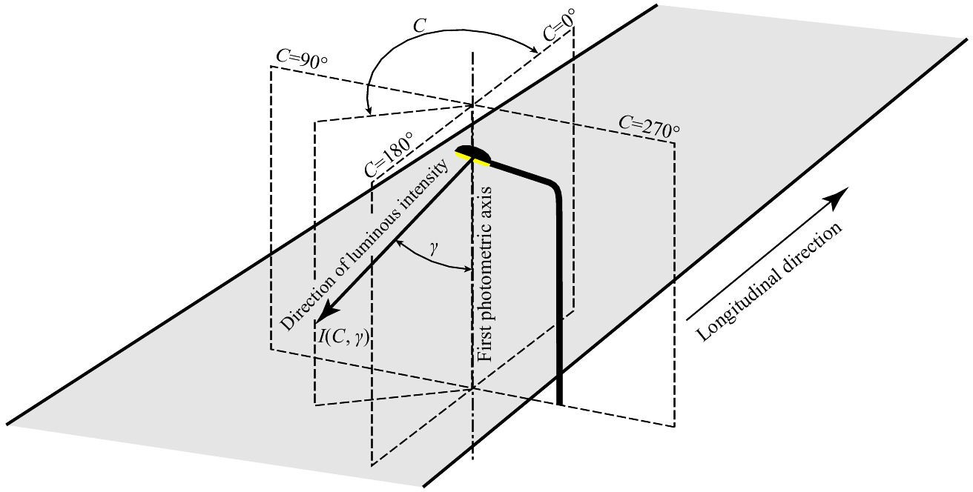

Figure 1 – (C,γ) co-ordinate system
Luminous intensity values are required over the range of angles which are important. In particular, values are required up to the maximum angle of elevation which is relevant for the intended application of the luminaire, with allowance being made for the maximum angle of tilt of the luminaire. Angular intervals stipulated in this report have been selected to give acceptable levels of interpolation error when the recommended interpolation procedure is used, and to keep the time taken for photometric measurements within practical limits.
In the (C,γ) co-ordinate system, luminous intensities for luminaires are required as follows:
- the angular interval in photometric azimuth, C, should at most be 5°;
- the angular interval in vertical photometric angle, γ, should at most be 2,5°.
NOTE 1 Some types of luminaires, in particular those with large gradients in the luminous intensity distributions, require smaller angular intervals. .
NOTE 2 Luminaires that could generate critical TI values in applications require smaller angular intervals in the critical directions.

Interpolation of luminous intensity data
Interpolation must be made in an I-table when the required luminous intensity direction lies between the directions of measured luminous intensities, as shown in Figure 2, where the luminous intensity I(C,γ) is required and it is necessary to interpolate between the four values of intensity lying closest to the direction C in azimuth and γ in elevation.

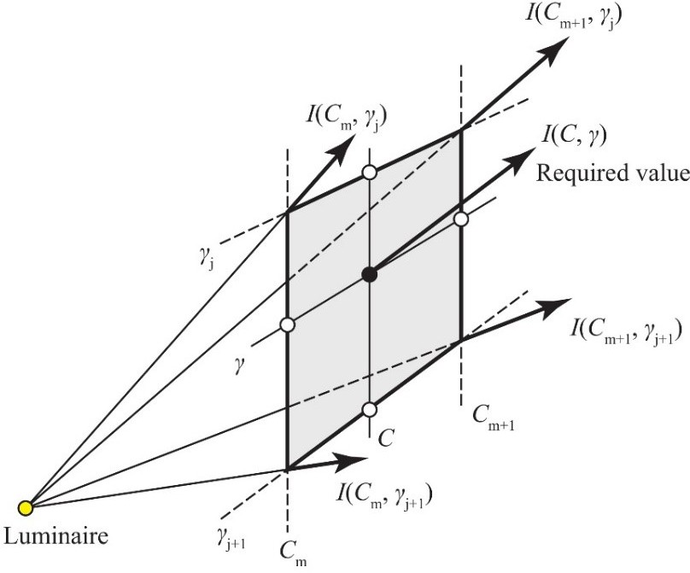

Figure 2 – Luminous intensities required for linear interpolation
Linear interpolation can be stated as an easy and accurate method to calculate required luminous intensity values. The usage of smaller angular intervals during measurement than those given in 5.1 can improve the accuracy of the linear interpolation.
To estimate the luminous intensity I(C,γ) it is necessary to interpolate between the four values of luminous intensity lying closest to the direction ( C,γ) as indicated in Figure 3.
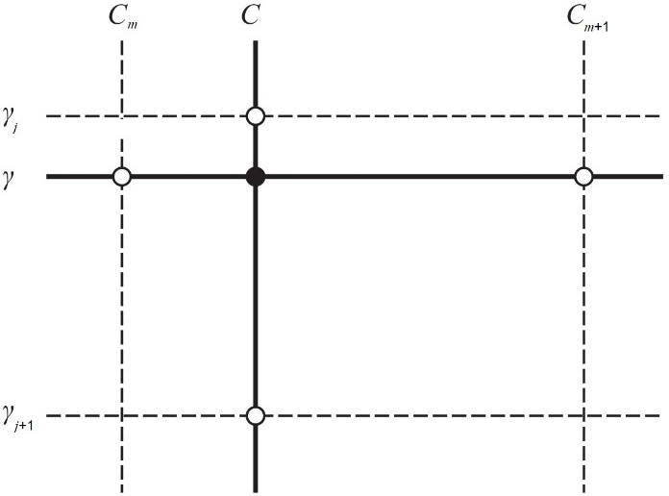

Figure 3 – Angles required for linear interpolation of luminous intensity
For linear interpolation, Equation (1) with n = 2 becomes:

y( x) = y
⎛ x − x2
⎞ + y
⎛ x − x1 ⎞
(2)

1 ⎜ x1 − x2 ⎟ 2 ⎜ x2 − x1 ⎟
Copyrighted material licensed to Toni Bonàs on 2026-05-06 for licensee's use only.
No further reproduction or networking is permitted. Distributed by Accuris, https://accuristech.com.
⎝ ⎠ ⎝ ⎠

This equation can be applied to either C or γ first. When it is first applied to angles in the C half-planes, C is substituted for x and I(C,γ) is substituted for y:
x = C y = I(C,γj)
x₁ = C_{m} y₁ = I(C_{m},γ_{j})
x₂ = C_{m+1} y₂ = I(C_{m+1},γ_{j})

With these substitutions and further adjustments Equation (2) becomes:
I(C,γ ) = I(C ,γ ) + C − Cm ⋅ (I(C ,γ ) − I(C ,γ )) . (3)

j m j
Cm+1 − Cm
m+1 j m j

Similarly:

I(C,γ

j+1

) = I(C

m,γ j+1) +

C − Cm
Cm+1 − Cm

⋅ (I(C

m+1,γ

j+1

) − I(C

m,γ j+1

)) . (4)

Then the Lagrange formula (Equation (2)) is applied to γ, hence γ is substituted for x and I(C,γ) is substituted for y:
x = γ y = I(C,γ)
x₁ = γ_{j} y₁ = I(C,γ_{j})
x₂ = γ_{j+1} y₂ = I(C, γ_{j+1})
With these substitutions the interpolation formula becomes:
γ − γ j

I(C,γ ) = I(C,γ j ) + γ

j+1 − γ j
⋅ (I(C,γ j+1) − I(C,γ j ))
(5)

Copyrighted material licensed to Toni Bonàs on 2026-05-06 for licensee's use only.
No further reproduction or networking is permitted. Distributed by Accuris, https://accuristech.com.
If this procedure is reversed by first carrying out interpolation in γ followed by interpolation in the C half-planes the same result will be obtained.

Road surface reflection data
Road surface reflection data are, conventionally, expressed in terms of the reduced luminance coefficient, r, multiplied by 10 000. Reduced luminance coefficient values are determined on the basis of β and ε angles. For the road lighting calculation that will be performed according to the conditions defined in this Technical Report, r-tables measured or evaluated considering CIE 144:2001 (CIE 2001) should be utilized.
The plan area covered by the data in the table is indicated in Figure 4 in terms of the mounting height of the luminaire, H, and in relation to the position of the luminaire and the direction of the observer.
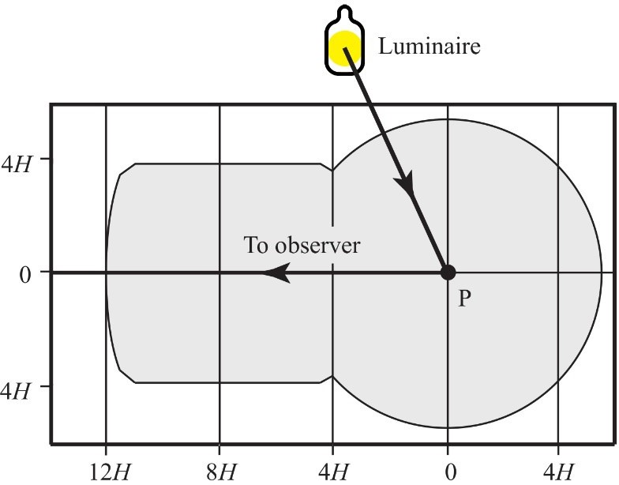

Figure 4 – Plan area covered by r tables

Copyrighted material licensed to Toni Bonàs on 2026-05-06 for licensee's use only.
No further reproduction or networking is permitted. Distributed by Accuris, https://accuristech.com.
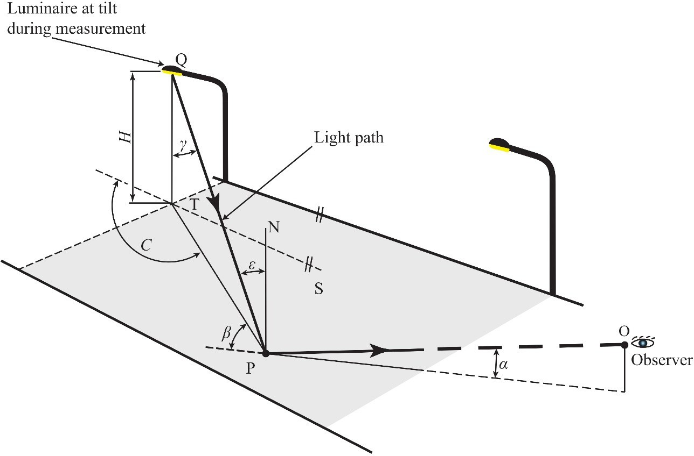
NOTE ST is the longitudinal direction, Q is the photometric centre of the luminaire, QT is a vertical axis, which is the first axis of the luminaire as tilt during measurement is zero on this figure, PN is the normal at P to the road surface, C is the photometric azimuth, β is the angle of deviation, γ is the vertical photometric angle, α is the angle of observation, ε is the angle of incidence.

Figure 5 – Angular relationships for luminaire, observer and point of observation
The reduced luminance coefficient varies according to the following angles, which are indicated in Figure 5:
ε angle of incidence at point P;
α angle of observation, i.e. angle between the line of sight of the observer and the surface of the carriageway (fixed at 1° downwards);
β angle of deviation, i.e. complementary angle between the vertical plane through the luminaire at Q and point P on the road surface, and the vertical plane through the observer O and point P.
Figure 5 shows that the vertical photometric angle, γ, is equal to the angle of incidence, ε. This is only true when the luminaire is used at its tilt during measurement and the rotation is zero. The reflection characteristics of the road surface may vary with the angle of view with r espect to the axis of the road, i.e. the surface may not be optically isotropic. The resulting variation in the reduced luminance coefficient is usually small and can be d isregarded.

Interpolation of reduced luminance coefficient data
In order to find the required interval values for the calculations from r-tables, again linear interpolation can be used as an easy and sufficiently accurate method.
NOTE Examples of r-tables can be found in CIE 144:2001.
When a value of reduced luminance coefficient, r, is required for values of β and tan ε lying between those given in the r-table, linear interpolation should be used. To estimate the reduced luminance coefficient r(β; tan ε) in the r-table it is necessary to interpolate between the four values of reduced luminance coefficient lying closest to the direction indicated by the values of

β and tan ε (see Figure 6). The ensuring mathematical procedure is similar to that described for the I-table as described in 5.2. The blank cells in r-tables should not be taken as presenting zero values, and interpolation should not be extended to this region.
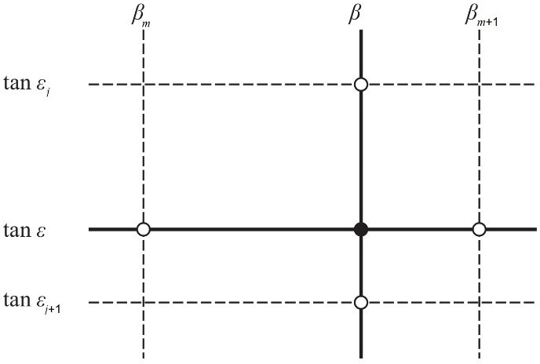

Figure 6 – Values required for interpolation procedure in the r-table

Calculation of the luminous intensity
To determine the luminous intensity directed from a luminaire to a point on the road surface it is necessary to find the vertical photometric angle, γ, and photometric azimuth, C, of the light path. Orientation, tilt in application, and rotation of the lum inaire must be taken into account. For this purpose mathematical sign conventions for measuring the distances on the road and for turning the luminaire about axes have to be established.
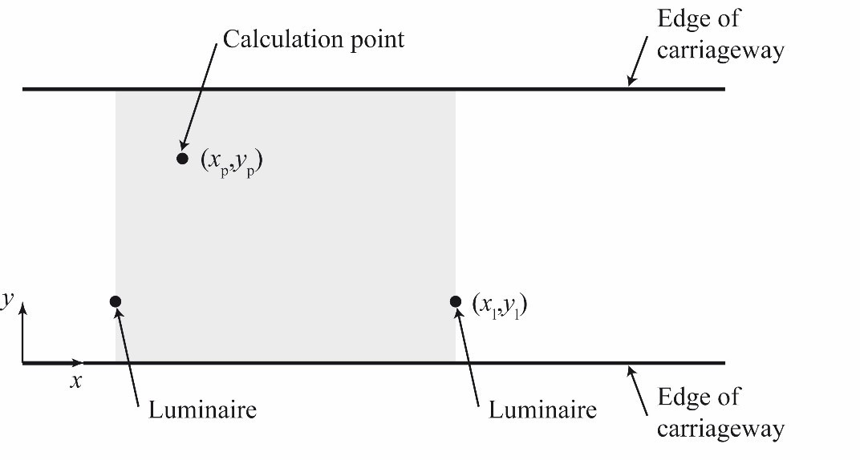
Figure 7 – (x,y) co-ordinate system for locating the luminaire and the calculation point in plan

Mathematical conventions for distances measured on the road
An (x,y) rectangular co-ordinate system on the road surface is used (see Figure 7). The abscissa is aligned with the reference direction which, for a straight road, lies in the longitudinal direction. The co-ordinates x and y are calculated as follows:
x = xp − xl

where
y = y
p − yl
(6)

(x_{p}, y_{p}) are the co-ordinates of the calculation point;
Copyrighted material licensed to Toni Bonàs on 2026-05-06 for licensee's use only.
No further reproduction or networking is permitted. Distributed by Accuris, https://accuristech.com.
(x_{l}, y_{l}) are the co-ordinates of the luminaire (its photometric centre).

NOTE In Figure 7 the origin of the co-ordinate system is not shown. For practical reasons it is favourable to place this origin in the lower left corner of the calculation field in order to obtain positive x and y co-ordinates for all grid points.
Copyrighted material licensed to Toni Bonàs on 2026-05-06 for licensee's use only.
No further reproduction or networking is permitted. Distributed by Accuris, https://accuristech.com.

Mathematical conventions for luminaire axes
The luminaire has three photometric axes of turning. To describe these it is necessary to extend the (x,y) co-ordinate system to three dimensions by means of the Z axis. The origin is taken to be at the photometric centre of the luminaire. Figure 8 shows the luminaire axes in relation to the (x,y,z) co-ordinate system, and the sense of the turning movements. The first photometric axis of the luminaire is fixed in space and the second and third photometric axes of the luminaire are mutually perpendicular and can be turned about the first axis. Principal diagrams for the turning of the luminaire in all three goniophotometry systems ((A,α), (B, β), (C, γ)) are given in CIE 121-1996 (CIE 1996).
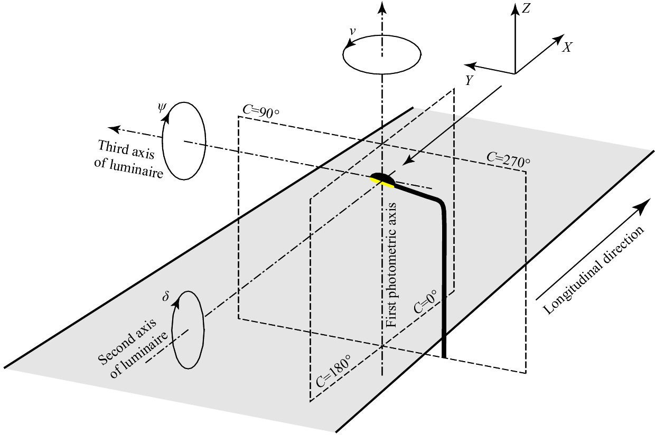

Figure 8 – Axes for turning the luminaire in relation to the (x,y,z) co-ordinate system
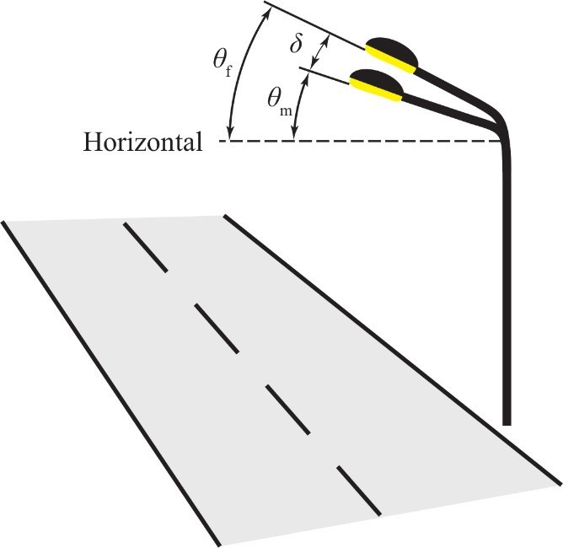
Figure 9 – Tilt during measurement, tilt in application, tilt for calculation

Figure 9 shows the relation between the tilt for calculation, the tilt during measurement and the tilt in application. From this it is evident that:

δ = θf − θm
where
δ is the tilt for calculation, in degrees;
θ_{f} is the tilt in application, in degrees;
θ_{m} is the tilt during measurement, in degrees.

Calculation of the photometric azimuth: luminaire not turned about photometric axes
According to Figure 8 the photometric azimuth, C, can be calculated as follows:

C = arctan y

x
The resulting values will be in the range –90° < C ≤ +90°.
(7)

(8)

The range of C values is dependent on the angular quadrant. It can be determined from Table 2.
Table 2 – Calculation of C from x and y

x | y | C (°) | Range of C (°)
0 | 0 | 0 | 0
> 0 | ≥ 0 | arctan y  x | 0 ≤ C < 90
0 | > 0 | 90 | 90
< 0 | ≥ 0 | 180 + arctan y  x | 90 < C ≤ 180
< 0 | ≤ 0 | 180 + arctan y  x | 180 ≤ C < 270
0 | < 0 | 270 | 270
> 0 | ≤ 0 | 360 + arctan y  x | 270 < C ≤ 360

Calculation of the vertical photometric angle: luminaire not turned about photometric axes
The vertical photometric angle, γ, can be calculated as follows:

γ = arctan
x 2 + y 2
H
. (9)

The resulting values will be in the range 0° ≤ γ < 90° .
Copyrighted material licensed to Toni Bonàs on 2026-05-06 for licensee's use only.
No further reproduction or networking is permitted. Distributed by Accuris, https://accuristech.com.

Calculation of the photometric azimuth and the vertical photometric angle: luminaire turned about photometric axes
The photometric azimuth, C, and the vertical photometric angle, γ, are determined in three stages:
- Substitution of ν, ψ, δ, x, and y in the equations (see Annex A for derivation):

x′ = x (cosν cosψ − sinν sinδ sinψ ) + y (sinν cosψ + cosν sinδ sinψ ) + H cosδ sinψ

y′ = −x sinν cosδ + y cosν cosδ − H sinδ
H ′ = −x (sinν sinδ cosψ + cosν sinψ ) − y (sinν sinψ − cosν sinδ cosψ ) + H cosδ cosψ
(10)

(11)

(12)

where
x and y are the longitudinal and transverse distances between the calculation point and the nadir of the luminaire as indicated in Figure 7;
H is the height of the luminaire above the calculation point;
ν, δ and ψ are the orientation, tilt in application, and rotation;
x′, y′ and H′ are distances on the co-ordinate system that has been turned through δ, ν and ψ. They correspond to x, y, and H in the unturned co-ordinate system and for calculation purposes may be regarded simply as intermediate variables (see Figure A.1).
NOTE In Equations (10), (11) and (12) attention must be paid to the value of H, which is usually the mounting height of the luminaire above the road surface for horizontal illuminance and road luminance evaluations. For the calculation of veiling luminance (see 8.4), the height of the observer’s eyes is set to 1,5 m by default. Similarly in vertical and semi-cylindrical illuminance evaluations, the calculation points considered are conventionally located at 1,5 m height above the ground. In that case H is substituted by (H − 1,5) in Equations (10), (11) and (12) to consider correctly the direction of luminous intensity.
- Calculation of photometric azimuth, C:
Evaluation of

C = arctan y′
x′
will give values in the range

−90° ≤ C < 90° .
(13)

The respective ranges of C values, dependant on the angular quadrant, can be determined from Table 3.
- Calculation of vertical photometric angle, γ:

γ = arctan x′2 + y′2
H ′ .

The resulting values will be in the range

−90° ≤ γ < 90° .

(14)

Copyrighted material licensed to Toni Bonàs on 2026-05-06 for licensee's use only.
No further reproduction or networking is permitted. Distributed by Accuris, https://accuristech.com.
The angular quadrant in which this lies is determined from Table 4.

Table 3 – Calculation of C from x′ and y′

x′ | y′ | C (°) | Range of C (°)
0 | 0 | 0 | 0
> 0 | ≥ 0 | arctan y′  x′ | 0 ≤ C < 90
0 | > 0 | 90 | 90
< 0 | ≥ 0 | 180 + arctan y′  x′ | 90 < C ≤ 180
< 0 | ≤ 0 | 180 + arctan y′  x′ | 180 ≤ C < 270
0 | < 0 | 270 | 270
> 0 | ≤ 0 | 360 + arctan y′  x′ | 270 < C ≤ 360
Table 4 – Calculation of γ

H′ | γ (°) | Range of γ (°)
> 0 | γ = x′2 + y′2  arctan  H ′ | 0 ≤ γ < 90
0 | 90 | 90
< 0 | γ = + x′2 + y′2  180 arctan  H ′ | 90 < γ ≤ 180

Calculation of photometric quantities

Luminance

Luminance at a point on a road surface
The maintained luminance at a point on a road surface is determined by applying the following formula or a mathematically equivalent formula

L = I(C,γ ) ⋅ fm ⋅ r ⋅10−4
∑
H ²

(15)

where
Copyrighted material licensed to Toni Bonàs on 2026-05-06 for licensee's use only.
No further reproduction or networking is permitted. Distributed by Accuris, https://accuristech.com.
L is the maintained luminance at the calculation point P, indicated in Figure 5 (in cd·m−2);
Σ indicates the summation of the contributions from all luminaires;
I(C,γ) is the luminous intensity in direction (C,γ) to the calculation point P, as indicated in Figure 1 (in cd);
f_{m} is the maintenance factor, calculated as product of the lamp luminous flux maintenance factor, lamp survival factor and luminaire maintenance factor (see CIE 154);
r is the reduced luminance coefficient, multiplied by 10 000, for a light ray incident with angular co-ordinates (β; tan ε);
H is the mounting height of the luminaires above the road surface (in m);
The luminous intensity, I(C,γ), is determined from the luminaire’s I-table after corrections have been made for the orientation, tilt in application, and rotation of the luminaire as indicated in Clause 6, with linear interpolation applied and multiplied by the initial luminous flux Φ (in klm)

of the sources in each luminaire, if necessary (if luminous intensity values are given in candelas per kilolumen (cd/klm)). Likewise, the reduced luminance coefficient for the appropriate values of β and tan ε is determined from the r-table using linear interpolation, if necessary.

Field of calculation for luminance
The field of calculation should be the typical area of the road that is of interest to the observer.
In the longitudinal direction on a straight road, the field of calculation should lie between two consecutive luminaires in the same row (see Figure 10), with the observer being located 60 m before the first luminaire in the field of calculation.
In the transverse direction, it should cover the whole carriageway width for roads without a central reservation, and the width of one carriageway for roads with a central reservation. However, this is limited by the applicability of the r-table. As stated in 5.3 the r-table is measured for an observer viewing the road at an angle of observation of 1° downwards ( see Figure 5). For a height of the observation point of 1,5 m, the observed point would lie 86 m ahead of the observer. It has been found that the r-table is applicable over a range of viewing angles between 0,5° and 1,5°, which results in the r-table being applicable to points lying between 57 m and 172 m approximately ahead of the observer.
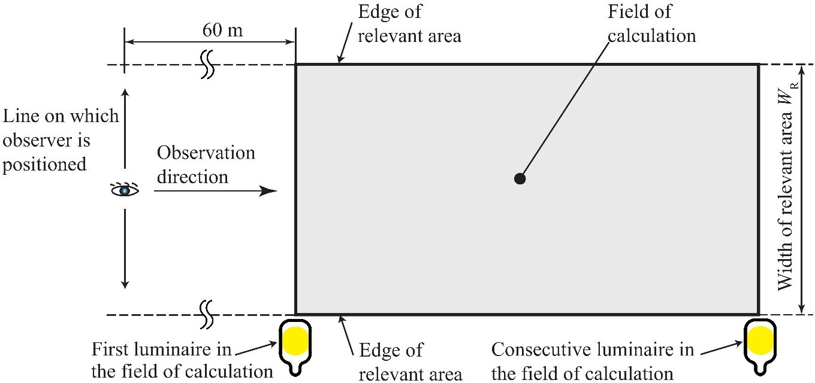

Figure 10 – Field of calculation for carriageway luminance

Position of calculation points
The calculation points should be evenly spaced in the field of calculation and located as indicated in Figure 11 for a driving lane.
- In longitudinal direction
The spacing, D, in the longitudinal direction is determined from the equation:

D = S

N

(16)

Copyrighted material licensed to Toni Bonàs on 2026-05-06 for licensee's use only.
No further reproduction or networking is permitted. Distributed by Accuris, https://accuristech.com.
where
D is the spacing between points in the longitudinal direction (in m);
S is the spacing between luminaires in the same row ( in m);
N is the number of calculation points in the longitudinal direction, chosen such that: if S ≤ 30 m: N = 10;
if S > 30 m: N is the smallest integer giving D ≤ 3 m.

The first transverse row of calculation points is spaced at a distance D/2 beyond the first luminaire (remote from the observer).
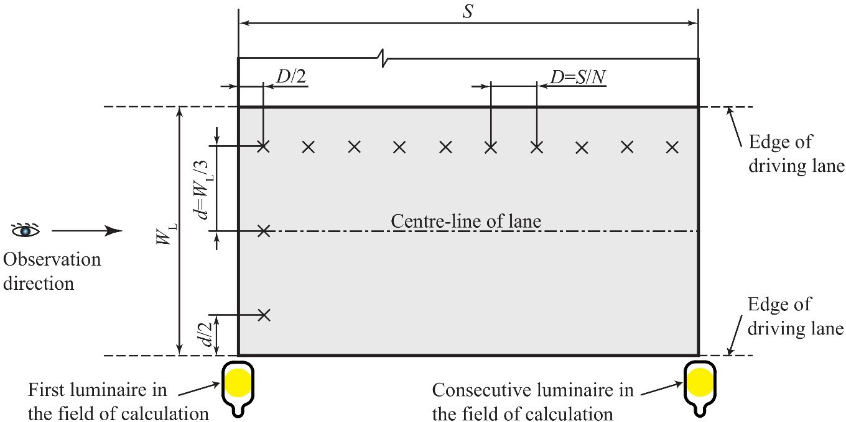

Figure 11 – Position of calculation points in a driving lane

- In transverse direction
The spacing, d, in the transverse direction is determined from the equation:
d = WL
3

(17)

Copyrighted material licensed to Toni Bonàs on 2026-05-06 for licensee's use only.
No further reproduction or networking is permitted. Distributed by Accuris, https://accuristech.com.
where
d is the spacing between points in the transverse direction ( in m);
W_{L} is the driving lane width (in m).
The outermost calculation points are spaced d/2 from the edges of the lane.
Where there is a hard shoulder and luminance information is required, the number and spacing of the calculation points should be the same as for a driving lane.

Position of observer
The angle of observation from the horizontal is fixed at 1° downwards, as stated in 5.3.
In the transverse direction the observer is placed in the centre of each driving lane in turn. The average luminance ( L ) (see 8.1), the overall uniformity of luminance (U_{o}) (see 8.2) and the threshold increment (f_{TI}) (see 8.4) are calculated for the entire carriageway for each position of the observer. The longitudinal uniformity of luminance (U_{l}) (see 8.3) is calculated for each
centre-line. The operative values of L , U_{o}, and U_{l} are the lowest in each case. Figure 12 gives
examples of the observer position in relation to the field of calculation.
NOTE For luminance calculations in some countries, three different concepts of observer positions and movements are recognized:
- fixed observer: position of the observer is aligned with the centre-line of each lane, the direction of observation is always parallel to the particular lane;

- simply moving observer: position of the observer is aligned with the centre-line of each lane, the direction of observation is aimed at transversal section of the carriageway at a fixed distance;
Copyrighted material licensed to Toni Bonàs on 2026-05-06 for licensee's use only.
No further reproduction or networking is permitted. Distributed by Accuris, https://accuristech.com.
- complex moving observer: position of the observer is aligned with each longitudinal line of calculation points, the direction of observation is aimed at points of this line at fixed distances (α = 1°).
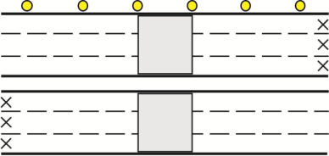
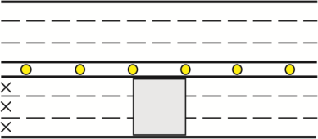

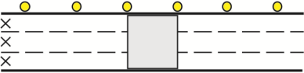  a) Six lane road with single-side luminaire arrangement | 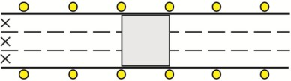  b) Six lane road with luminaire arrangement in the central reservation
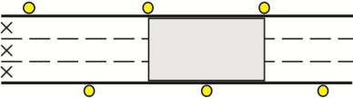  c) Three lane road with single-side luminaire arrangement | 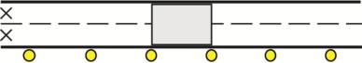  d) Three lane road with double-side opposing luminaire arrangement
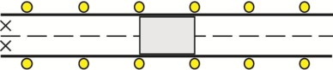  e) Three lane road with double-side staggered luminaire arrangement | 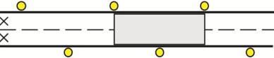  f) Two lane road with single-side luminaire arrangement
g) Two lane road with double-side opposing luminaire arrangement | h) Two lane road with double-side staggered luminaire arrangement

Figure 12 – Examples of positions of observation points in relation to the field of calculation of luminance for right-hand driving conditions

Number of luminaires included in calculation
For each calculation point, all the luminaires which make a significant contribution to the luminance should be included in the calculation. The contributing luminaires are those lying in the plan area of the r-table, which approximates to a rectangle of dimensions 5 H by 17 H, and

by its symmetry can be used to cover an area 10 H by 17 H (H being the mounting height of a luminaire – see Figure 4). As a consequence, it is only necessary to consider luminaires which are situated within five times the mounting height from the calculation point towards the observer, 12 times the mounting height from the calculation point away from the observer, and five times the mounting height on either side of the calculation point. Figure 13 shows an example.
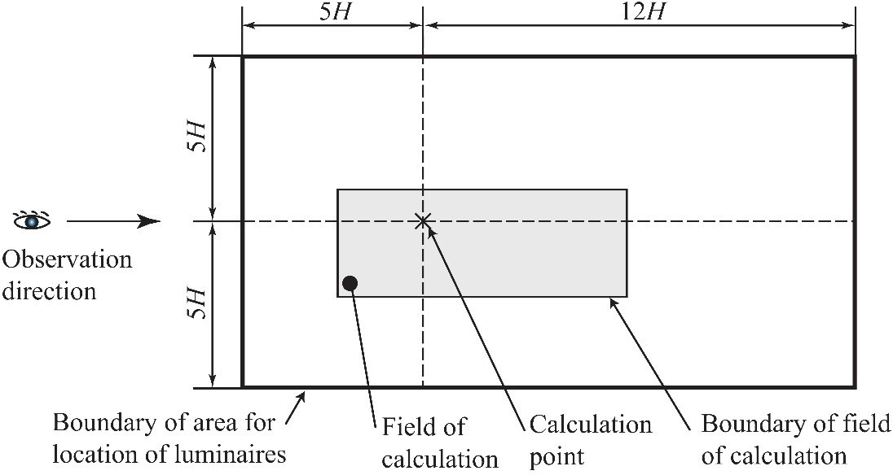
Figure 13 – Luminaires which may contribute to the luminance at a calculation point

Illuminance
In this report the calculation of two forms of illuminance are considered. These are:
- Planar illuminance on a horizontal plane, usually the carriageway surface or footway surface, referred to as horizontal illuminance.
- Semi-cylindrical illuminance, 1,5 m above the surface of interest. The semi-cylindrical illuminance varies with the direction of interest. For a street this is taken to be in a designated longitudinal direction.

Horizontal illuminance
The maintained horizontal illuminance at a point (P) should be calculated with the following formula or a mathematically equivalent formula:

Eh,m
= I(C,γ ) cos³ε fm
H ²
∑

(18)

where
Copyrighted material licensed to Toni Bonàs on 2026-05-06 for licensee's use only.
No further reproduction or networking is permitted. Distributed by Accuris, https://accuristech.com.
E_{h,m} is the maintained horizontal illuminance at the calculation point P, see Figure 5 (in lx);
Σ indicates summation of the contributions from all the luminaires;
I(C,γ) is the luminous intensity in direction to the calculation point P (in cd);
γ is the vertical photometric angle (in °);
ε is the angle of incidence of the light at the calculation point P, see Figure 5 (in °);
f_{m} is the maintenance factor, calculated as product of the lamp luminous flux maintenance factor, lamp survival factor and luminaire maintenance factor (see CIE 154);
H is the mounting height of the luminaire above the road surface (in m);
Figure 5 applies for some parameters in Equation (18).

Semi-cylindrical illuminance
The maintained semi-cylindrical illuminance at a point (P) should be calculated with the following formula or a mathematically equivalent formula:

Esc,m
= I(C,γ )(1+ cosαsc )cos²ε sinε fm
π(H − 1,5 m)2
∑

(19)

Copyrighted material licensed to Toni Bonàs on 2026-05-06 for licensee's use only.
No further reproduction or networking is permitted. Distributed by Accuris, https://accuristech.com.
where
E_{sc,m} is the maintained semi-cylindrical illuminance at the calculation point P (in lx);
Σ indicates summation of the contributions from all the luminaires;
I (C;γ) is the luminous intensity in direction to the calculation point P (in cd);
γ is the vertical photometric angle (in °);
α_{sc} is the angle between the vertical plane containing the luminous intensity vector and the vertical plane at right angles to the flat surface of the semi-cylinder, as shown in Figure 14 (in °);
ε is the angle between the light incidence and the normal of the horizontal plane, at the calculation point P (in °)
f_{m} is the maintenance factor, calculated as product of the lamp luminous flux maintenance factor, lamp survival factor and luminaire maintenance factor (see CIE 154);
H is the mounting height of the luminaire above the road surface (in m);

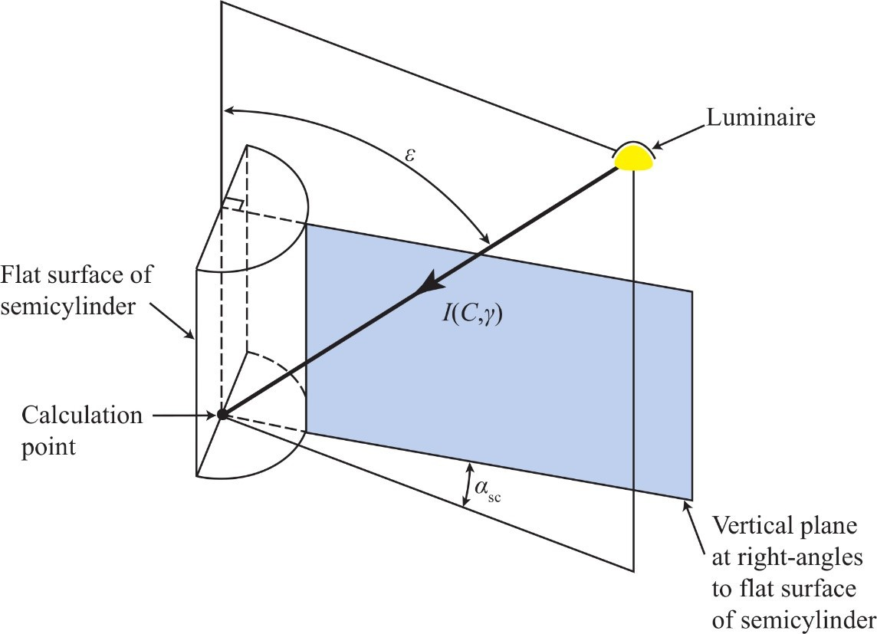
Figure 14 – Angles used in the calculation of semi-cylindrical illuminance

Carriageway
      - Field of calculation
The field of calculation should be the typical area of the road which is of interest to the driver. It should be bounded by the edges of the carriageway and by transverse lines through two consecutive luminaires. For staggered installations consecutive luminaires will be on opposite sides of the road.

Position of calculation points
The calculation points should be evenly spaced in the field of calculation and the ir number per driving lane (see Figure 15) should be chosen as follows:
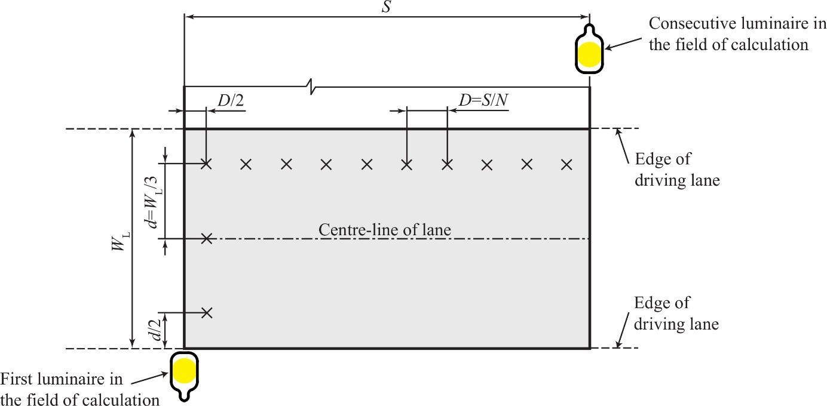
Figure 15 – Calculation points for illuminance in a driving lane

- In longitudinal direction
The spacing in the longitudinal direction should be determined from the equation:
D = S

N

(20)

where
D is the spacing between points in the longitudinal direction ( in m);
S is the spacing between luminaires (in m);
N is the number of calculation points in the longitudinal direction with the following values: if S ≤ 30 m: N = 10
if S > 30 m: N is the smallest integer giving D ≤ 3 m.
The first row of calculation points is spaced at a distance D/2 beyond the first luminaire.
- In transverse direction

d = WL
3

(21)

Copyrighted material licensed to Toni Bonàs on 2026-05-06 for licensee's use only.
No further reproduction or networking is permitted. Distributed by Accuris, https://accuristech.com.
where
d is the spacing between points in the transverse direction ( in m);
W_{L} is the width of the driving lane (in m).
The spacing of points from the edges of the driving lane is D/2 in the longitudinal direction, and
d/2 in the transverse direction, as indicated in Figure 15.

Number of luminaires included in calculation
Luminaires which are situated within five times the mounting height on each side of the calculation point should be included in the calculation.

Footways and cycle paths
The field of calculation should be the typical area of the footway or cycle path which is of interest to the pedestrian or cyclist, respectively. Similarly as for the carriageway it should be bounded by the edges of the footway or cycle path and by transverse lines through two consecutive luminaires.
The calculation points should be evenly spaced in the field of calculation ( see Figure 15 indicating the situation for a driving lane) and their number should be chosen as follows:
- In longitudinal direction
If the footways or cycle paths are of the same lighting arrangement as the carriageway, they may be considered together with the carriageway for determining the spacing of the calculation points in the longitudinal direction, otherwise 7.2.3.2 a) applies for the footways and cycle paths according to their lighting arrangement.
- In transverse direction

d = WF
F n

(22)

Copyrighted material licensed to Toni Bonàs on 2026-05-06 for licensee's use only.
No further reproduction or networking is permitted. Distributed by Accuris, https://accuristech.com.
where
d_{F} is the spacing between points in the transverse direction (in m);
W_{F} is the width of the footway or cycle path (in m);
n is the number of points in the transverse direction with the following values: if W_{F} ≤ 1,0 m: n = 1;
if W_{F} > 1,0 m: n is the smallest integer giving d_{F} ≤ 1 m.
The points adjacent to the edge of the footway or cycle path should be spaced from this edge at one half of the spacing between points. If n = 1, the points lie in the centre line of the footway or cycle path.
For the number of luminaires included in the calculation, requirements given in 7.2.3.3 apply.

Areas of irregular shape
Areas of irregular shape may include conflict areas, residential roads, and areas where pedestrian activity predominates.
The calculation points should cover the relevant area and should be on a square grid with a spacing between points no greater than 5 m. A spacing of about 1 m should be considered for areas of particular interest or importance.
The orientation(s) for semi-cylindrical illuminance should be in the main direction(s) of pedestrian movement.
For the number of luminaires included in the calculation, requirements given in 7.2.3.3 apply.

Calculation of quality characteristics
Quality characteristics relating to luminance or illuminance should be obtained from the calculated grid values of luminance or illuminance without further interpolation.
For calculation of initial average illuminance or initial average luminance, the maintenance factor is not considered (f_{m} = 1,0). For average luminance or average illuminance after a stated period, the maintenance factor for the luminaire in the environmental conditions of the installation after the stated period should be considered. CIE 154:2003 (CIE 2003) gives further guidance on determination of the maintenance factor for road lighting installations.
Values of quality characteristics should be presented with the number of decimal places in accordance with Table 5.

Table 5 – Required number of decimal places for presentation of quality characteristics

Value | L | E ,Emin, EF , EF,min | U_{o,} U_{l}, U_{h} | fTI | REI
< 10 | 2 | 2 | 2 | 2 | 2
10 to 50 | 1 | 1 | n/a | 1 | n/a
- 50 | 0 | 0 | n/a | 0 | n/a

Average luminance of the road surface

The average luminance, L , is calculated as the arithmetic mean of the luminances obtained at the grid points in the field of calculation.

Overall uniformity of road surface luminance
The overall uniformity, U_{o}, is calculated as the ratio of the lowest to the average luminance in the field of calculation.

Longitudinal uniformity of road surface luminance
The longitudinal uniformity, U_{l}, is calculated as the ratio of the lowest to the highest luminance in the longitudinal direction along the centre-line of each lane, including the hard shoulder in the case of motorways. The number of points in the longitudinal direction , N , and the spacing between them should be the same as those used for the calculation of average luminance.
The observer's position should be in line with the row of calculation points.

Threshold increment (TI)
The threshold increment, f_{TI}, is calculated for the installation in its initial state when luminaires are new and light sources emit the initial luminous flux. It is calculated from the following formula or a mathematically equivalent formula:

with

f TI
= 65 Lv
L0,8
(23)

n
Lv = ∑Lv,k
k =1

(24)

where

L is the average initial luminance of the road surface (in cd·m−2);
L_{v} is the initial equivalent veiling luminance (in cd·m−2);
L_{v,k} is the initial equivalent veiling luminance produced by the k^{th} luminaire (in cd·m−2);
n is the number of luminaires considered.
The contribution of the kth luminaire to the initial equivalent veiling luminance, L_{v,k}, is calculated either by formula (25) or (26):

⎡ ⎛ A ⎞ 4 ⎤ Ek

if 1,5° < θ

≤ 60° (25)

Lv,k = 9,86 ⎢1+ ⎜ 66,4 ⎟ ⎥ θ 2 k
⎢⎣ ⎝ ⎠ ⎥⎦ k

⎡ ⎛ A ⎞ 4 ⎤ Ek
Ek

if 0,1° < θ

≤ 1,5° (26)

Lv,k = 5 ⎢1+ ⎜ 62,5 ⎟ ⎥ θ 2 + 10 θ 3 k
Copyrighted material licensed to Toni Bonàs on 2026-05-06 for licensee's use only.
No further reproduction or networking is permitted. Distributed by Accuris, https://accuristech.com.
⎢⎣ ⎝ ⎠ ⎥⎦ k k

where
Copyrighted material licensed to Toni Bonàs on 2026-05-06 for licensee's use only.
No further reproduction or networking is permitted. Distributed by Accuris, https://accuristech.com.
E_{k} is the illuminance (in lx) at the centre of the observer’s eye produced by the k^{th} luminaire in its new state and with lamps emitting their initial luminous flux, on a plane normal to the line of sight and at the height of the observer's eye; the observer's eye, at a height 1 ,5 m above road level, is positioned in the centre line of each lane in turn, as indicated in Figure 16, and longitudinally at a distance of 2,75 ( H − 1,5 m) in metres, where H > 2 m is the mounting
height, in front of the field of calculation. The line of sight is 1° below the horizontal and in a vertical plane in the longitudinal direction passing through the observer's eye (see Figure 16). When the mounting height is H ≤ 2 m, the longitudinal distance of the observer ahead to the first luminaire in front of the field of calculation is fixed to 60 m.
θ_{k} is the angle between the line of sight and the line passing through the observer’s eye and the centre of the k^{th} luminaire (in °);
A is the age of the observer (in years).

Equations (23) to (26) are valid for 0,05 cd m⁻² < L < 5 cd m⁻². Formula (26) is drawn from CIE 146:2002/CIE 147:2002 (CIE 2002).
For road lighting installation design the age of the observer is conventionally taken as 23 years.
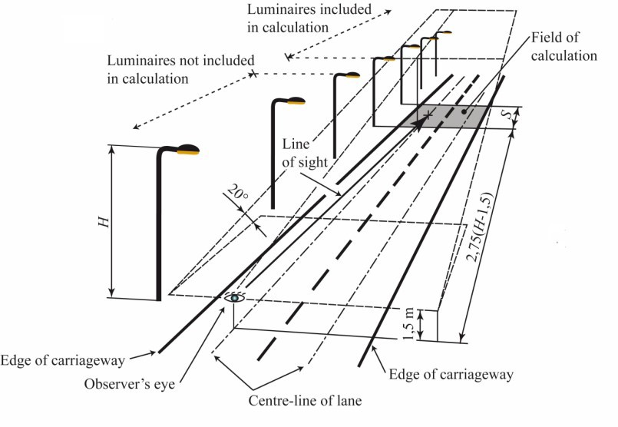
Figure 16 – Situation for the calculation of threshold increment TI
The summation is performed for the first luminaire in the direction of observation and luminaires beyond, up to a distance ≤ 500 m in each luminaire row or for the whole installation length if it is less than 500 m.
If H > 2 m, luminaires above a screening plane which is inclined at 20° to the horizontal, which passes through the observer's eye, and which intersects the road in a transverse direction, should be excluded from the calculation. If H ≤ 2 m, the luminaires located outside the cone of vision of 60° half angle of aperture whose axis is collinear to the observer line of sight should be excluded from the calculation.
The calculation is commenced with the observer in the initial position stated above and repeated with the observer moved forwards in increments which are the same in number and distance as

are used for the longitudinal spacing of luminance points. The procedu re is repeated with the observer positioned in the centre of each lane using in each case the initial average road luminance appropriate to the observer position.
The maximum value of TI found is the operative value.

Edge illuminance ratio (EIR)
The width of all four strips adjacent to the edges of the carriageway should be equal to the width of the adjacent traffic lane, W_{L} (see examples in Figure 17). The edge illuminance ratio, R_{EI}, must be calculated on both edges separately (Equations (27) and (28)) and the minimum value of them is the operative value (Equation (29)). In case of motorways with central reservation, EIR is calculated only for the edge opposite to the central reservation and the result becomes the operative value.

REI,1-2

REI,4-3
= Eh,strip1
Eh,strip2

= Eh,strip4 Eh,strip3
(27)

(28)

REI = min(REI,1-2; REI,4-3 )
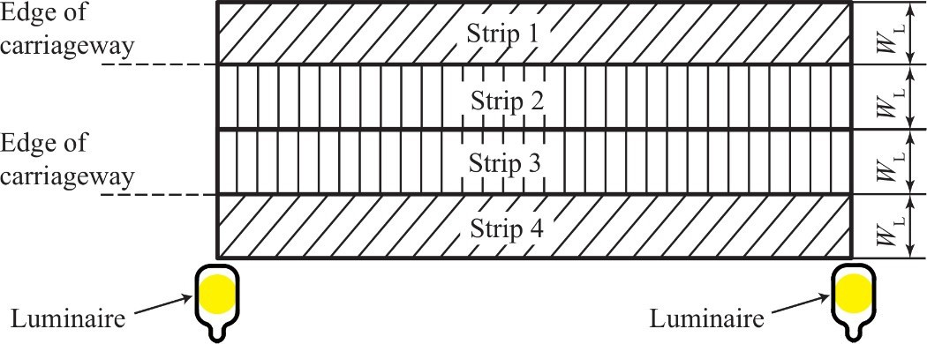
- Width of strips equals the width of traffic lane W_{L} in case of two-lane carriageway

(29)

Copyrighted material licensed to Toni Bonàs on 2026-05-06 for licensee's use only.
No further reproduction or networking is permitted. Distributed by Accuris, https://accuristech.com.
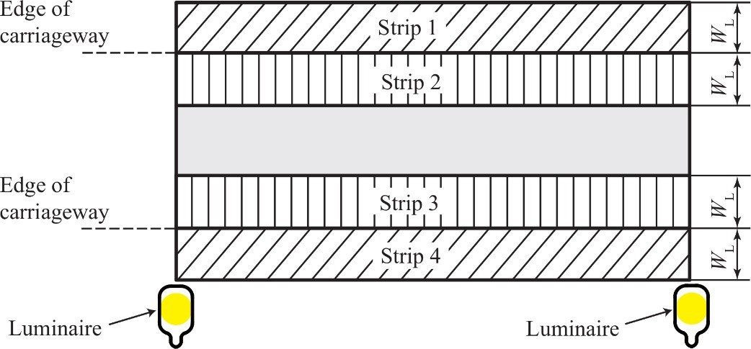
- Width of strips equals the width of traffic lane W_{L} in case of carriageway with more than two lanes
Figure 17 – Examples of location and width of strips for calculation of the edge illuminance ratio

Average illuminance on the carriageway
Copyrighted material licensed to Toni Bonàs on 2026-05-06 for licensee's use only.
No further reproduction or networking is permitted. Distributed by Accuris, https://accuristech.com.
The average illuminance on the carriageway, Eh , is calculated as the arithmetic mean of the
illuminances obtained at the grid points of the calculation field according to 7.2.3.2.
For conflict areas, pedestrian areas, and other irregularly shaped areas the procedure in 7.2.5 should be followed.

Minimum illuminance on the carriageway
The minimum illuminance on the carriageway, E_{min}, is taken as the lowest value of the illuminances obtained at the grid points of the calculation field according to 7.2.3.2.
For conflict areas, pedestrian areas, and other irregularly shaped areas the procedure in 7.2.5 should be followed.

Average illuminance on the footway or cycle path
The average illuminance on the footway or cycle path, EF , is calculated as the arithmetic mean
of the illuminances obtained at the grid points of the calculation field according to 7.2.4.

Minimum illuminance on the footway or cycle path
The minimum illuminance on the footway or cycle path, E_{F,min}, is taken as the lowest value of the illuminances obtained at the grid points of the calculation field according to 7.2.4.

Uniformity of illuminance
The uniformity of illuminance, U_{h}, is calculated as the ratio of the minimum illuminance to the average illuminance obtained at the grid points of the calculation field according to 7.2.3.2 and 7.2.4, respectively.

Test data
Methodology in this document demands for numerous calculations what normally implies the necessity of its implementation to a calculation software. Results of computer programs may differ in data presentation on different platforms, due to rounding principles and other influencing factors. To help developers of computer programs in verifying and confirming the validity of their results, test data and benchmark resulting values are provided in Annex B.

Ancillary data
When photometric performance data are prepared for an installation, the following ancillary data should be declared:
- identification of the luminaires, including the setting of the optical components and lamp s, if applicable;
- identification of I-table;
- identification of r-table;
- orientation of the luminaires;
- tilt during measurement of the luminaires;
- tilt in application of the luminaires;
- rotation of the luminaires;
- identification of the light sources;
- luminous flux of the light sources on which the calculations are based;
- maintenance factors applied;
- definition of the area of calculation;
- position of the luminaires in space or a numerical description;

Copyrighted material licensed to Toni Bonàs on 2026-05-06 for licensee's use only.
25
No further reproduction or networking is permitted. Distributed by Accuris, https://accuristech.com.
CIE 140:2019
- mounting height of the luminaires;
- age of observer for the calculation of threshold increment;
- any deviations from the procedures given in this report.
Items c) and n) are not required when the calculations are solely those of illuminance.

Annex A
Derivation of equations for turning the luminaire about the three axes of the co-ordinate system

Method
A rectangular co-ordinate system is adopted in which the position of a point P, is specified in co-ordinates (x, y, z) on X, Y, Z axes.
Matrices are used to express the turning 1 of the co-ordinate system about each of the three axes. These are composed, in the correct order, to give a new co-ordinate system X’, Y’, Z' in which the combined effect of the three turning movements is expressed in terms of co-ordinates (x’, y’, z’).
The first axis of the luminaire lies in the Z axis, the second axis of the luminaire lies in the X axis, and the third axis of the luminaire lies in the Y axis (see Figure 8 and Figure A.1). The origin of the co-ordinate system lies at the photometric centre of the luminaire

General matrix for turning movements about the axes of the co-ordinate system
Consider a right-handed Cartesian co-ordinate system with axes U, V, and W. Let the co-ordinates of a point P in this system be (u, v, w). If the system is turned anti-clockwise through an angle ω about the W axis, the co-ordinates (u’, v’, w’) of a stationary point P in the turned system can be found from the expression:

⎡⎣u′ v′
⎡cosω
w′⎤⎦ = ⎡⎣u v w⎤⎦ ⎢ sinω
− sinω cosω
0⎤
0⎥ = ⎡⎣(u cosω+ v sinω) ( − u sinω + v cosω)

w ⎤⎦

(A.1)

⎢ 0 0 1⎥
⎣ ⎦

For convenience adopt the notation

⎡cosω
T -1 = ⎢ sinω
− sinω 0⎤
cosω 0⎥

(A.2)

W ⎢ 0 0 1⎥
⎣ ⎦

where the negative power of T signifies that the matrix is the inverse of the matrix for turning the point P through the angle ω about the origin, and the suffix W refers to the axis of turning.

Turning movement about the Z axis

⎡cosν
T -1 = ⎢ sinν
−sinν 0⎤
cosν 0⎥

(A.3)

Z ⎢ 0 0 1⎥
⎣ ⎦

Turning movement about the X axis
⎡ 1 0 0⎤

T -1 = ⎢0 cosδ −sinδ ⎥
(A.4)

    - ⎢0 sinδ cosδ ⎥
Copyrighted material licensed to Toni Bonàs on 2026-05-06 for licensee's use only.
No further reproduction or networking is permitted. Distributed by Accuris, https://accuristech.com.
⎣ ⎦

—————————
1 The more usual term for “turning” in texts describing the application of matrices is “rotation”. In this document rotation is used in the specialized sense for describing the turning of a luminaire about the Y axis

Turning movement about the Y axis
⎡ cosψ 0 sinψ ⎤

T -1 = ⎢
0 1 0⎥
(A.5)

    - ⎢− sinψ 0 cosψ ⎥
⎣ ⎦

Sequence of turning movements
The effect of the turning movements will depend on the sequence in which they are applied. To be in accordance with application in the field this must be first orientation, second tilt, and third rotation.

Composition of turning movements
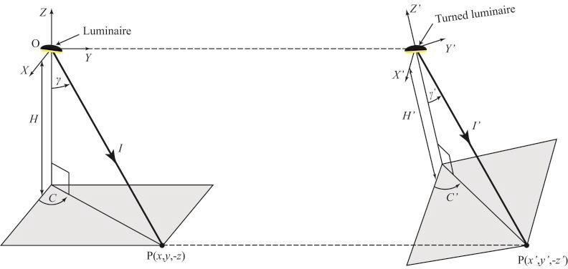
a) before turning movements b) after turning movements
Figure A.1 – Result of turning movement
Figure A.1 shows how the primed values x′, y′, z′, H′, C′, I′, and γ′ after turning, relate to the unprimed values before turning has taken place. The position of P does not change with respect to the position of the luminaire, so the vector OP in Figure A.1 a) equals the vector OP in Figure A.1, b). x′, y′, z′, and H′ are found by multiplying the matrices for the three turning movements together. The order must be as indicated below to be in accordance with A.6.

⎡⎣x′
y′ z′⎤⎦ = ⎡⎣x y z⎤⎦ ⎡T -1 . T -1 . T -1⎤
(A.6)

⎣ Z X Y⎦
where
⎡T -1 . T -1 . T -1⎤=
⎢⎣ Z X Y ⎥⎦

⎡ cosν ⋅ cosψ - sinν ⋅ sinδ ⋅ sinψ
−sinν ⋅cosδ
cosν ⋅ sinψ +sinν ⋅ sinδ ⋅cosψ ⎤
(A.7)

⎢sinν ⋅cosψ +cosν ⋅ sinδ ⋅ sinψ
cosν ⋅cosδ
sinν ⋅ sinψ - cosν ⋅ sinδ ⋅cosψ ⎥

⎢ - cosδ ⋅ sinψ
sinδ
cosδ ⋅cosψ ⎥

⎣ ⎦

Substitution of this in Equation (A.1) gives
Copyrighted material licensed to Toni Bonàs on 2026-05-06 for licensee's use only.
No further reproduction or networking is permitted. Distributed by Accuris, https://accuristech.com.
x′= x ( cosν ⋅cosψ - sinν ⋅ sinδ ⋅ sinψ )+ y ( sinν ⋅cosψ + cosν ⋅sinδ ⋅sinψ ) - z ⋅cosδ ⋅sinψ

y′= - x ⋅ sinν ⋅ cosδ + y ⋅ cosν ⋅ cosδ + z ⋅ sinδ

(A.8)

(A.9)

z′= x ( cosν ⋅ sinψ + sinν ⋅ sinδ ⋅ cosψ )+ y ( sinν ⋅ sinψ - cosν ⋅ sinδ ⋅ cosψ )+ z ⋅ cosδ ⋅ cosψ
(A.10)

Now from Figure A.1: H′ = −z′, and H = −z, so
x′= x ( cosν ⋅cosψ - sinν ⋅ sinδ ⋅ sinψ )+ y ( sinν ⋅cosψ + cosν ⋅sinδ ⋅sinψ )+ H cosδ ⋅sinψ

y′= - x sinν ⋅ cosδ + y cosν ⋅ cosδ - H sinδ

H ′= - x ( cosν ⋅ sinψ + sinν ⋅ sinδ ⋅ cosψ ) - y ( sinν ⋅ sinψ - cosν ⋅ sinδ ⋅ cosψ )+ H cosδ ⋅ cosψ

(A.11)

(A.12)

(A.13)

Copyrighted material licensed to Toni Bonàs on 2026-05-06 for licensee's use only.
No further reproduction or networking is permitted. Distributed by Accuris, https://accuristech.com.

Initial attitude of a luminaire
δ, ν and ψ are the angles through which the luminaire is turned from its angular attitude when it is photometrically measured. In practice luminaires are photometrically measured at an angular attitude such that ν and ψ are not off-set from zero. However, they may be measured with the luminaire tilted, in which case δ = θ_{f} − θ_{m} (see Figure 9).

Annex B
Copyrighted material licensed to Toni Bonàs on 2026-05-06 for licensee's use only.
No further reproduction or networking is permitted. Distributed by Accuris, https://accuristech.com.
Test data for assessment of the accuracy of road lighting computer programs
In this annex, a set of test data and benchmark values of results is provided in order to verify calculated values of road lighting computer programs, which use methods defined in this document.

Test data sets
Calculation examples are given for seven different test situations shown in Figure B.1. General assumptions are as follows:
    - I-tables of luminaires can be downloaded as part of a data set from the CIE website (http://files.cie.co.at/957_TC_4-15_Test_Data.zip) in different luminaire data file formats (CIE, IES, Eulumdat, Phillum, Inr, CIBSE TM14, LTLi) and as Excel and ASCII files. Files with photometric luminaire data are numbered corresponding to each particular situation (see Table B.2).
    - The road surface is taken as R3 for all situations.
    - The maintenance factor is taken as 0,80 for all situations.
    - The age of the observer is 23 years.
All above mentioned pre-defined parameters are intended for testing purposes only and must not be supposed as recommended by this document. Input parameters to test situations are given in Table B.1 and Table B.2.
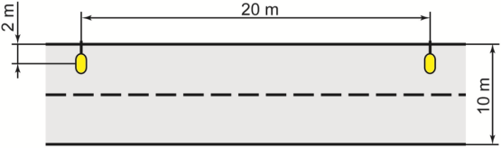
- Situation 1
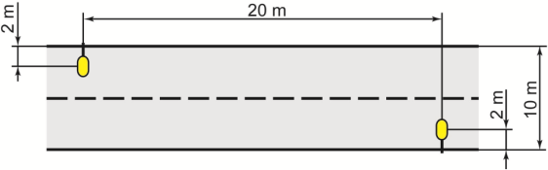
- Situation 2
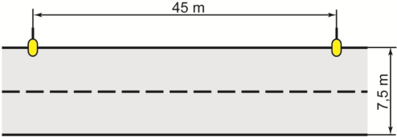
- Situation 3 Figure B.1 – Test situations

Copyrighted material licensed to Toni Bonàs on 2026-05-06 for licensee's use only.
CIE 140:2019
d) Situation 4
e) Situation 5
f) Situation 6
g) Situation 7
Figure B.1 – Test situations (continued)
30
No further reproduction or networking is permitted. Distributed by Accuris, https://accuristech.com.

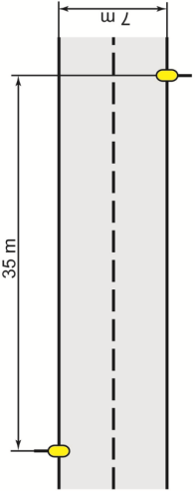
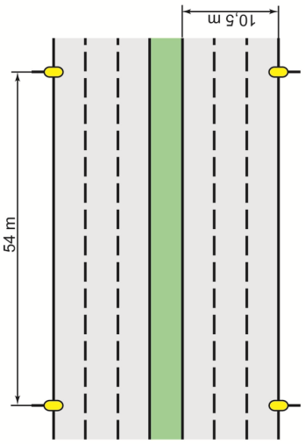
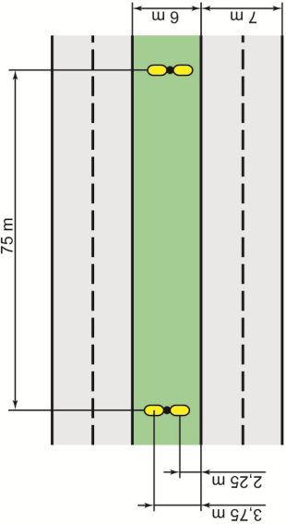
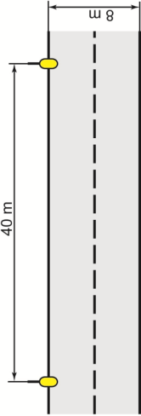

Table B.1 – Input parameters for test situations

Test sit. | S  m | W_{R}  m | n_{L} | H  m | T  m | δ  ° | Lamp type* | P  W | Φ  lm
1 | 20 | 10,0 | 2 | 4 | 2 | 0 | CFL | 24 | 1 800
2 | 20 | 10,0 | 2 | 4 | 2 | 0 | CFL | 24 | 1 800
3 | 45 | 7,5 | 2 | 10 | 0 | 5 | HPS | 100 | 10 500
4 | 35 | 7,0 | 2 | 8 | 0 | 5 | HPS | 100 | 10 500
5 | 54 | 10,5 | 3 | 12 | 0 | 5 | HPS | 100 | 10 500
6 | 75 | 7,0 | 2 | 18 | −2,25 | 5 | HPS | 250 | 32 000
7 | 40 | 8,0 | 2 | 10 | 0 | 5 | LPS | 90 | 13 000
KEY S = Spacing between luminaires (m), W_{R} = Width of relevant area (m), n_{L} = Number of lanes, H = mounting height (m), T = Overhang (m), δ = Tilt for calculation (°), P = Nominal wattage of lamp used per luminaire (W), Φ = Initial rated luminous flux of the lamp used per luminaire (lm)
* Abbreviations of lamp types: compact fluorescent lamp (CFL), high-pressure sodium lamp (HPS), low-pressure sodium lamp (LPS).

Table B.2 – Description and data files for test situations

Test sit. | Lighting Arrangement | Fig. | Luminous Intensity Data (file name) | Road Surface | Road Surface Data  (file name)
1 | Single-sided left | B.1 a) | Sit1.* | R3 | R3-TAB.dat
2 | Staggered | B.1 b) | Sit2.* | R3 | R3-TAB.dat
3 | Single-sided left | B.1 c) | Sit3.* | R3 | R3-TAB.dat
4 | Staggered | B.1 d) | Sit4.* | R3 | R3-TAB.dat
5 | Opposite with central reservation 1,5 m | B.1 e) | Sit5.* | R3 | R3-TAB.dat
6 | Central, twin brackets 180° | B.1 f) | Sit6.* | R3 | R3-TAB.dat
7 | Single-sided left | B.1 g) | Sit7.* | R3 | R3-TAB.dat
NOTE Luminous intensity data and road surface data with the specified file names can be downloaded as part of a data set from the CIE website (http://files.cie.co.at/957_TC_4-15_Test_Data.zip). Asterisks (*) in file names indicate that different file extensions are provided for different file formats (such as ldt, ies, phl, etc.).

Benchmark values of test results

Table B.3 shows the benchmark values for average luminance, L , overall uniformity of luminance, U_{o}, longitudinal uniformity of luminance, U_{l}, threshold increment (TI), f_{TI}, equivalent

veiling luminance, L_{v}, edge illuminance ratio (EIR), R_{EI}, average illuminance,
of illuminance, U_{h}.
Eh , and uniformity

The test of a computer program is passed if the results for all seven situations individually match the benchmark values in Table B.3.
Copyrighted material licensed to Toni Bonàs on 2026-05-06 for licensee's use only.
No further reproduction or networking is permitted. Distributed by Accuris, https://accuristech.com.

NOTE Benchmark values in Table B.3 have been acquired by means of a specifically composed computer program.
Copyrighted material licensed to Toni Bonàs on 2026-05-06 for licensee's use only.
No further reproduction or networking is permitted. Distributed by Accuris, https://accuristech.com.
Table B.3 – Benchmark values of test results of road lighting quality criteria

Test situation | Observer | L  cd·m−2 | U_{o} | U_{l} | fTI  % | L_{v}  cd·m−2 | REI | Eh  lx | U_{h}
1 | 1 | 0,26 | 0,14 | 0,56 | 141 | 0,877 | 0,32 | 2,50 | 0,28
 | 2 | 0,26 | 0,15 | 0,64 | 49,7 | 0,314
2 | 1 | 0,26 | 0,35 | 0,33 | 101 | 0,636 | 0,47 | 2,50 | 0,32
 | 2 | 0,26 | 0,32 | 0,33 | 99 | 0,626
3 | 1 | 0,55 | 0,52 | 0,68 | 11,5 | 0,130 | 0,64 | 7,80 | 0,34
 | 2 | 0,60 | 0,54 | 0,70 | 11,3 | 0,138
4 | 1 | 0,88 | 0,54 | 0,53 | 13,8 | 0,228 | 0,61 | 12,0 | 0,49
 | 2 | 0,87 | 0,51 | 0,53 | 13,8 | 0,227
5 | 1 | 0,44 | 0,45 | 0,79 | 11,0 | 0,105 | 0,76 | 7,00 | 0,28
 | 2 | 0,42 | 0,57 | 0,71 | 10,4 | 0,095
 | 3 | 0,41 | 0,67 | 0,75 | 7,10 | 0,063
6 | 1 | 1,17 | 0,49 | 0,62 | 11,5 | 0,239 | 0,67 | 16,2 | 0,50
 | 2 | 1,30 | 0,49 | 0,72 | 8,00 | 0,181
7 | 1 | 0,53 | 0,45 | 0,84 | 15,6 | 0,173 | 0,62 | 7,00 | 0,50
 | 2 | 0,58 | 0,46 | 0,91 | 10,6 | 0,127
NOTE Values of quality characteristics relating to luminance are given individually for each driving lane.

References
Copyrighted material licensed to Toni Bonàs on 2026-05-06 for licensee's use only.
No further reproduction or networking is permitted. Distributed by Accuris, https://accuristech.com.
CIE 1996. CIE 121-1996. The Photometry and Goniophotometry of Luminaires . Vienna: CIE. CIE 2000. CIE 136-2000. Guide to the Lighting of Urban Areas . Vienna: CIE.
CIE 2001. CIE 144:2001. Road Surface and Road Marking Reflection Characteristics. Vienna: CIE.
CIE 2002. CIE 146:2002/147:2002. CIE Collection on Glare 2002. Vienna: CIE. CIE 2003. CIE 154:2003. Maintenance of Outdoor Lighting Systems . Vienna: CIE.
CIE 2010. CIE 115:2010. Recommendations for the Lighting of Roads for Motor and Pedestrian Traffic. Vienna: CIE.
CIE 2011. CIE S 017/E:2011. ILV: International Lighting Vocabulary. Vienna: CIE.

Further reading
CIE 1976. CIE 31-1976. Glare and Uniformity in Road Lighting Installations . Vienna: CIE. LiTG 1991. LTAG Publikation Nr. 14. Methoden der Beleuchtungsstärke- und
Leuchtdichteberechnung für Straßenbeleuchtung .

